HR Form V
Revised: 091512008

NOTICE OF ACTION

( ) WRITTEN REPRIMAND ( X ) SUSPENSION ) DISMISSAL ( )DEMOTION Effective date of action :..:Ju=l. -v....l.."9- _, 2021=- .m. DEPARTMENT: So l idW atse ---------------------- DIVISION.: _
EMPLOYEE: .._.A...,n"d"'"r"e''w""''-H''""i....,ll- - - - --- CLASSIFICATION: Environmental Manager

You are hereby notified of your suspension for _!Q_ days on the date shown above. You are to report back to work at 8:00
a.m. on August 2, 2011.

ACTION(s), REASONS & BASIS FOR ACTION (complete below)
Failure to effectively manage and enforce the waste hauling contract - see attached

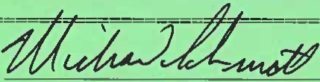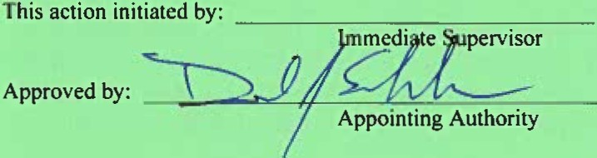Department Head
Date: 2. /1( fL.._{ ___

AFFlDAVIT OF EMPLOYER:
I hereb\ certify that on the \ u-¥- day of
-.:l" ") , 20_lL, 2:00 f .m.
I \7 delivered, forwarded by mail
a true copy of the foregoing notice to the employee
named herein.
.dwvA i;:.;..J""b
STAT EMENT OF EMPLOYEE:
I hereby certify that I have read the above charge(s)
and specificatio11} and have received a true copy of same on this Ic_ day of .::fv I , 20f,/,
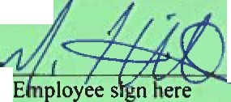and my signature in no way implies that I agree with th aciton ·-

NOTICE OF APPEAL: See reverse side for Rule governing Action, Date of Notice and employee right of appeal.

Copies to: Human Resources Appointing Authority Employee

ACTION

COMMENCEMENT OF ACTION: An action by an appointing authority shall be commenced by filing with the Civil Service Board, notice of such action and serving a copy of the notice on the employee against whom the action is taken.

IMPACT OF AN ACTION: Actions shall become a pennanent part of the employee's personnel file and shall not be removed. In the event an employee receives an action listed below, said action shall defer the annual increase for the time period listed below:

ACTION MINIMUM TIME

I st ( l day) suspension
2nd or subsequent {I day) suspension or any suspension (2 - 30 days)
None

6 months

NOTICE OF ACTION: Notice of the action on an employee shall state, in writing, the nature of the action taken, the effective date of the action, and the duration thereof. The notice shall specify the date, time and place {where applicable) and the factual basis for such action in sufficient detail to provide the employee an opportunity to prepare a defense. The notice shall be signed by the appointing authority, or its authorized representative, and filed with Human Resources no more than ten (I 0) days after the effective date of the action.

SERVICE OF NOTICE OF ACTION ON EMPLOYEE:Service of notice of act ion on an employee shall be made by delivering a copy of the notice to the employee in person or by legal service of process. If the employee is absent without leave from his/her employment, a copy of the notice will be forwarded by certified United States mail to the last known address of the employee as reflected in the Official Personnel Record.

APPEAL BY EMPLOYEE TO BOARD; RIGHT TO APPEAL, ETC.: An employee who has been demoted, suspended or dismissed by his, or her appointing authority from a position in the classified service and, who has been duly appointed to such position in accordance with the Civil Service Act and these rules, and who has attained status by serving the required probationary period, shall have the right to appeal such action to the Civil Service Board. To appeal, the employee shall, within (10) days after the charges are filed with the board, or after the date of service upon him of notice of such action, whichever
is later, file his appeal in writing in the office of the Civil Service Board; it shall be sufficient for the
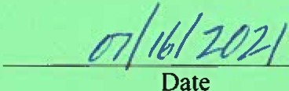employee to deny the charge(s) or reasons given for the action taken, and request a hearing before the Civil Service Board. The appeal shall be signed by the employee or his attorney and shall state the address to which a copy of hearing and other pleading_or papers shall be served upon the appointing authority or its representative who initiated the action against the employee by delivery or regular United States mail to its address of record.

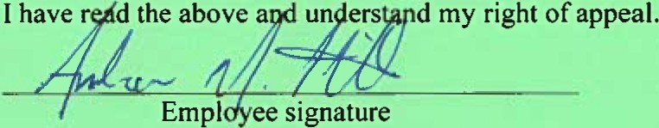

Andrew Hill
Notice of Action- Suspension
July 16, 2021

In May and June 2021, the County conducted an extensive investigation into several complaints made regarding the operations of the solid waste division. The investigation was completed and a final report was provided to interested parties on July 1,2021.

The investigation concluded that while there were not improper dealings between the County and a waste hauler contractor,there was a lack of operating procedures,effective communication between staff and the contractor and a positive working relationship which caused a perception of favoritism and mistrust that the contract was being fully enforced.

During the discussion in June 2020 and subsequent implementation on January 1,2021, of the Amended Residential Solid Waste and Recycling Collection Franchise Agreement, there was a lot of time spent considering contract compliance and enforcement.To that end,the amended agreement imposed certain requirements and liquidated damages that were not formerly contemplated. The Board of County Commissioners and senior leadership provided specific expectations for the compliance and enforcement of this amended agreement.

As the Environmental Manager you are responsible for the effective daily management and enforcement of all the department's contracts. The lack of follow through and oversight provided on this contract has caused senior leadership to have a reduction in confidence.Over the last several weeks,you have stepped up to be part ofthe solution to fix the identified issues and have showed a desire and the ability to correct this deficiency. Your recent actions have produced a sense that confidence can be restored.

As a result of the investigation, you will be suspended without pay for two weeks beginning on July 19,
2021. Any future occurrences of this nature will likely result in further disciplinary action up to and including termination of employment.

