HR Fonn V
Revised: 09,'512008

NOTICE OF ACTION

( X ) WRITIEN REPRIMAND ( ) SUSPENSION
) DISMISSAL
( ) DEMOTION

Effective date of action ""Jul=y,J..-1..:-,6_ , 202=1,__ .m.

DEPARTMENT: So l idW as te ------------ ---- DIVISION:

EMPLOYEE: Michael Schmidt CLASSIFICATION: Environmental Director

You are hereby notified of your suspension for a.m. on , 20_.
days on the date shown above. You are to report back to work at __

ACTION(s), REASONS & BASIS FOR ACTION (complete below)
failure to effective! oversee the management and enforcement of the waste hauling contract -see attached

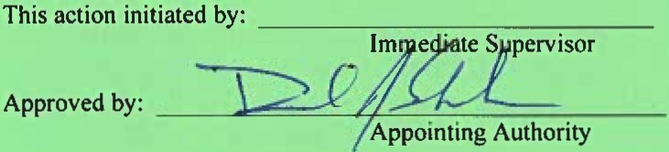Date:
Department Head
7 f,G 1"2:- ----

AFFIDAVIT OF EMPLOYER:
I hereby certify that on the \ u day of
:J'"v\i , 20 '2.\ , 2!00 p .m.
Z delivered, forwarded by mail
a true copy of the foregoing notice to the employee
named herein.
STATEMENT OF EMPLOYEE:
I hereby certify that I have read the above charge(s)
and specifications and have received a true copy of same on this l day of :!u\1.4. 202.\, and my signa ure in no is that I agree with
#
'/j

the?j tion.

"Y Employee sign here

NOTICE OF APPEAL: See reverse side for Rule governing Action, Date ofNotice and employee right of appeal.

Copies to: Human Resources Appointing Authority Employee

Michael Schmidt
Notice of Action-Reprimand
July 16, 2021

In May and June 2021, the County conducted an extensive investigation into several complaints made regarding the operations of the solid waste division. The investigation was completed and a final report was provided to interested parties on July 1,2021.

The investigation concluded that while there were not improper dealings between the County and a waste hauler contractor,there was a lack of operating procedures, effective communication between staff and the contractor and a positive working relationship which caused a perception of favoritism and mistrust that the contract was being fully enforced.

During the discussion in June 2020 and subsequent implementation on January 1,2021,of the Amended Residential Solid Waste and Recycling Collection Franchise Agreement, there was a lot of time spent considering contract compliance and enforcement.To that end,the amended agreement imposed certain requirements and liquidated damages that were not formerly contemplated. The Board of County Commissioners and senior leadership provided specific expectations for the compliance and enforcement of this amended agreement.

As the Environmental Director you are responsible for overseeing the effective management and enforcement of contracts. The lack of follow through and oversight provided on this contract has caused senior leadership to have a reduction in confidence in the solid waste department. Over the last severa• weeks,you have stepped up to be part of the solution to fix the identified issues and have showed a desire and the ability to correct this deficiency. Your recent actions have produced a sense that confidence can be restored.

Any future occurrences of this nature will likely result in further disciplinary action up to and including termination of employment.

....

